7 ELEMENTS OF DESIGN NOTES Name ___________________Date________Per____
1. Drama – D________________________
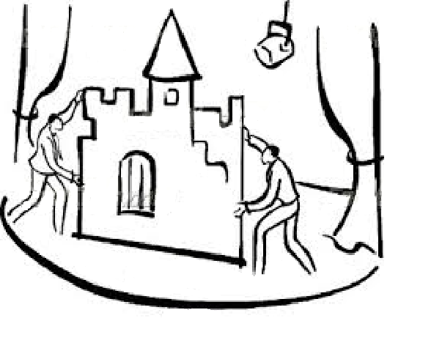
2. Students – S_______________________
3. Like – L___________________________
4. To – T____________________________
5. Create – C_________________________
6. Silly – S___________________________
7. Theatre – T________________________

1. _________________________ (EMPHASIS)
2. _________________________ is outline, may be _____________________or free-form, natural or stylized, realistic
or ______________________ .
- More form fitting – ____________ __________________
- ______________ – lower class
- Consider psychological influences
  - ______________– infinite, eternal, feminine
  - ______________ – unmovable, unimaginative
  - ______________ – uplifting, secure foundation
  - ______________ – calming, restful, wealth

3. Different ________________ cause different psychological connotations:
* ____________________________ – Dignity, ____________________, hope, spirituality
* ____________________________ – emotional stability, calmness, ______________________
* ____________________________ – ___________________, strife, uncertainty, concentration
* ____________________________ – ease, comfort, ____________________, expanse
* ____________________________ – ___________, shattered dreams, injustice, __________
* ____________________________ – ________________________ (if ________________ with
contrasting colors)

4. _____________________ (MOOD)
_______________ – the ____________________ feeling of the play the audience ___________________.
Affected by all the technical elements ______________________.

5. __________________________
- Make sure the colors of all different production areas are working together to produce the effect that the director wants.
- Note - Lighting can change the color of your set and costumes!

________________ – the lightness or darkness of a color (______________vs. ___________________)
  - ___________ – (pastels)have more ______________, suggest __________, comedy , informality
  - ________________– have more ____________, suggest ________________, seriousness
- ___________ – the _______________________ of a color
- __________________ (saturation) – the ____________________ or dullness of a ______________
  - _____________ colors advance – Red, Orange, yellow (stimulating_______________, comedies)
  - _____________colors recede – Blue, _____________, Violet (tranquility, ___________, serious)
- Different colors express ____________________ ideas:
___________________– calm, _____________, formal, spiritual, pure, truthful, ________________________
___________________ – exhilarating, ____________________, lively
___________________– aggressive, ________________________, bloody, _________________, strong
___________________ – cheerful, ______________________, youthful, _________________________
___________________ – fanciful, _________________________
___________________ – _______________________, eternal, reborn, _______________________
___________________ – ____________________, soothing, ____________________
___________________ – ____________________, mystic, regal
___________________– ________________, depressing, negative, ________________________
___________________ – ____________________, common, _________________________________
___________________ – melancholic, ___________________, gloomy, _________________________
___________________ – truthful, ____________, chaste, ________________________, peaceful

6. _______________________________________
1. What type of theatre ______________________ is the performance in?
    - Proscenium, in the round, small theatre, large theatre
- Different __________________ will require different ________________ ___________________.
- ______________________ – (measured by ___________________ of a _________________ being)
- ______________________ – _________________ distribution of emphasis
- ____________________ – _________________ and ________________________.
2. What is the __________________ of the performance? Period, ______________________, etc.

7. ___________________________________________
- ___________________ – the relative _____________________ or smoothness of an _____________
- ___________________ – _________________, satin, finished, ex. ___________ ________, good guys,
- ___________________ – burlap, ___________________, rocky, ex. _____________ ________, villains
- ___________________– __________ pattern, chiffon, ___________________, vulnerable
- ___________________– _______________, fur, more ___________________, sturdy

