Tools of the Trade
The Board

Sliders Dial Command Keys Blackout Button Power Button

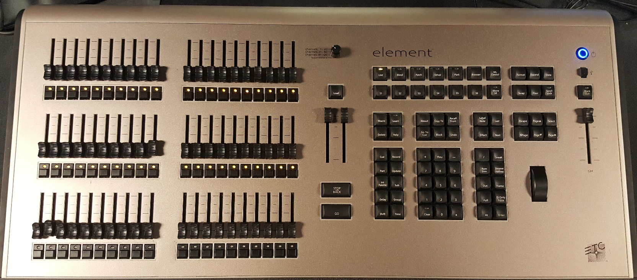

Go/Back Buttons Number Keys Wheel Master Slider

Sliders- Control the main 120 lights’ brightness from 0% (down) to 100% (up)
Dial- Rotate to change which set of lights the sliders control (1-40, 41-80, or 81-120)
Go/Back Buttons- Used to Go to the next cue or Back to the previous cue
Number Keys- Used to type numbers as a part of a command, and/or to select lights
Command Keys- Used to type commands in the Command bar on the Right Screen
Wheel- Spin to increase or decrease all selected lights’ brightness; all selected lights increase or decrease at the same rate regardless of starting brightness
Master Slider- Slide up and down to set all the lights at a percent of the intensity that the cue and/or sliders would have them be at. Ex: 50% on the master slider cuts all lights to half of what they would otherwise be at, 100% to 50% and 50% to 25%.
Blackout Button- Press to blackout lights until it is pressed again
Power Button- Press once and wait to turn the board and screens on; press multiple times to power off (Save beforehand)

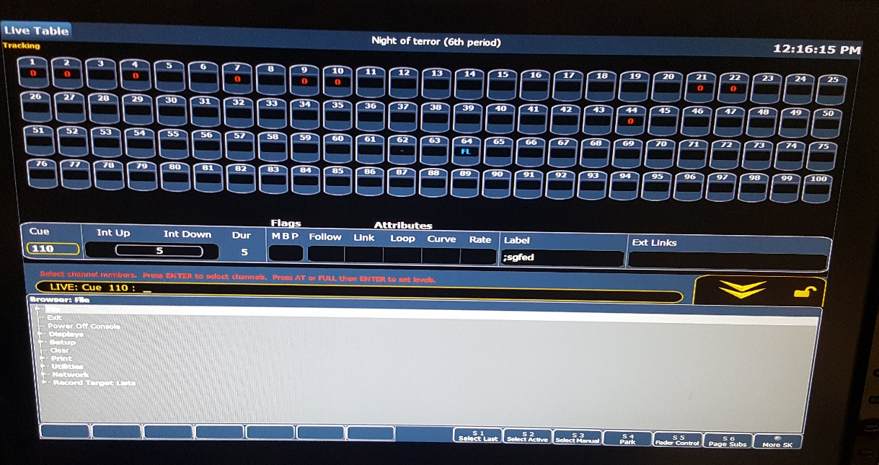
Right Screen
Light Icons - Icon representing a single light (or pair of connected lights
Command Bar - Area in which commands are typed
Up/Down Widget - Click on this to bring the menu up or down
Menu - Menu where you save/make/delete files (shows) and can power off the board
Light Number - The number of the light, which appears on the bars near where the physical light hangs; click here to select the light
Light Level - The intensity level of the light, from 0% (0) to 100% (FL)

Left Screen
Cue Number - Number by which each cue in the list is identified
Time - Time over which the cues are transitioned to
Label - Labels describing the cues they are paired with
Line - Grab and drag to the right using the mouse to give labels more space

