TYPES OF COMEDY
PARODY
To make a __________ of or make fun of in a form that imitates or misrepresents somebody or something's style, usually in a _________________way.
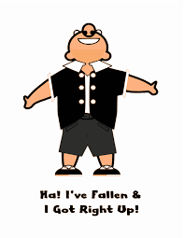
Spoof: make a parody of; "The students spoofed the teachers."
_______________ __________________.
Often the title and characters names will be changed in a humorous way.
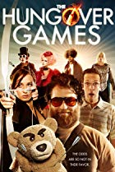
EXAMPLE MOVIE PARODIES
- Robin Hood Men in Tights (1993)
- Scary Movie 3 (2003)
- Spaceballs (1987)
- The Princess Bride (1987)
- Young Frankenstein (1974)
- Hot Shots (1991)
- Airplane (1980)

SATIRE
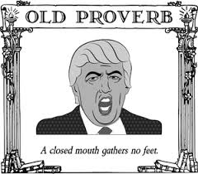
Primarily a _________________ genre or form, although in practice it can also be found in the _____________ and ___________________arts. In satire, vices, follies, abuses, and shortcomings are held up to ____________________, ideally with the intent of _________________ individuals, and society itself, into __________________. ________________________ is a popular choice of subject.

Although satire is usually meant to be funny, its greater purpose is constructive __________________ _____________________, using ______________ and _________________________as a weapon.
EXAMPLE MOVIE SATIRES
- A Clockwork Orange (1971)
  - Violence, drug use, curing criminals
- Logan’s Run (1976)
  - Unrestrained technology, environmental abuse
- MASH (1970)
  - Anti-Vietnam war
- Dr Strangelove ,or How I learned to Stop Worrying and Love the Bomb (1964)
  - Politicians, cold war, arms race

FARCE/TRAVESTY
A lighthearted work in which highly _______________________ plot situations,_________________________ characters, and often _____________________________elements are used for humorous effect.
A ludicrous, ___________________ show; a _______________________.
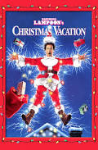
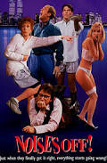
EXAMPLE MOVIE FARCES
- The Hangover (2009)
- Some Like It Hot (1959)
- A Fish Called Wanda (1988)
- There’s Something About Mary (1998)
- Arsenic & Old Lace (1944)
- Noises Off (2004)
- National Lampoons Series
(What is lampoon?)

BLACK or DARK COMEDY
- Black humor or dark comedy often refers to the juxtaposition of__________________ and _________________________elements to create a disturbing effect. Black comedy, is a sub-genre of comedy and satire where grave topics like _________________, __________________, ____________, marital ___________________, human _____________________ or domestic __________________ are treated in a satirical manner.
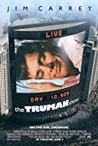
EXAMPLE MOVIE DARK COMEDIES
- Bad Santa (2003)
- Arsenic and Old Lace (1944)
- Heathers (1989)

- Swimming with Sharks (1994)
- Serial Mom (1994)
- The Truman Show (1998)

