TYPES OF STAGES & SETS NOTES
Describe each of the following types of stage in terms of where the audience compared to the stage and draw a thumbnail sketch of it

PROSCENIUM –

THRUST –

TRAVERSE –

IN THE ROUND –

**__________________ - A ________________ of what the _____________ will look like from the
_________________ point of view.

Drawn to _________________ - An _________________ in real life reduced in _______________ by a certain amount in
order to fit on a page. Example: ¼” + 1 1’

** Scale ________________ / _________________ plan, or a _____________________ plan all mean a
scale ____________________ of the ______________________ view of a set showing the exact location of all _____________________, _____________________ and _______________________.

** Set Design _______________________ - A ____ _____________________ scale depiction of the set

______________________ - An __________ ________ view drawing arranged in a ____________ for use in the
________________________ of a set
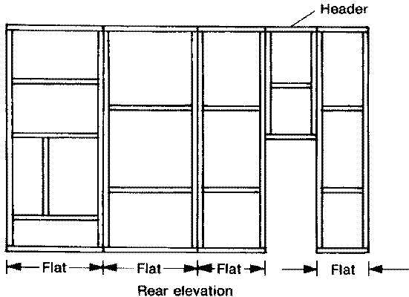

______________________ set – Remains the _______________ throughout the play regardless of
__________________ changes

Standard ______________ set - ____ or _____ wall set, often with a _________________

_______________ set – Several _________________ units that can be __________________ and _______________ on
stage to create several ___________________

____________________ set - _________________ and ____________________ that can be left empty or filled with
__________________ or doors - no _____________

___________ __________ set / _______________ set – uses ______ dimensional pieces of scenery, like rocks or bushes
cut out of ________________

________________ set – uses _________________ as a backdrop
Good use – for _________________ or ______________

____________ Set – use ______________ or _______________ flats, any height or width, usually freestanding

__________________ / ________________ set - ___________________ piece of scenery that can be rotated to show
different scenes

